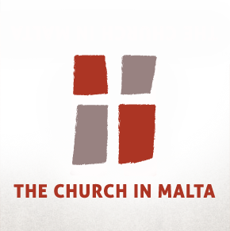
Safeguarding Commission
Reporting Form
Please complete this form in as much detail as possible, omitting any sections where you do not know the correct information, and return to Andrew Azzopardi, Head of Safeguarding, Archdiocese of Malta, PO Box 90, Head Office, Marsa, MRS1000 or by email on safeguarding@maltadiocese.org.
Pastoral Functionary’s Details (This is the person you are reporting to the Curia)
Name of Pastoral Functionary
Date of Birth or age (if known)
Contact details (Please include all relevant contact details including telephone nos, email and address)
Role
Parish/School/Organisation
Child’s or Vulnerable Adult’s details
Name of Child or Vulnerable Adult
Date of birth (if known)
Details of Concerns
Nature of allegation  ☐Sexual abuse  ☐Online/internet abuse | ☐Physical abuse  ☐Emotional abuse |  | ☐Neglect  ☐Other: Verbal abuse
Details of alleged incident
Please include details of the alleged incident or concern. You may wish to include the following:
- date/s of alleged abuse
- location
- injuries sustained
- potential witnesses
- how you became aware of the allegation
- any other relevant information
Action taken
Please specify whether this allegation was referred to the Police or other authorities.
Please add whether the Curia has permission to disclose this information to other relevant agencies (e.g. Police, Appoġġ, etc). Be aware that the Church may, in any event, be under legal obligation to refer the matter to the Police.
Person filing the report
Please include your Name, Organisation (if relevant), Role and contact details (telephone numbers, email and address)
ID Card Number
Date and Signature

